
BAKE SALE
Raising funds for
Woodlarks Camp Site Trust
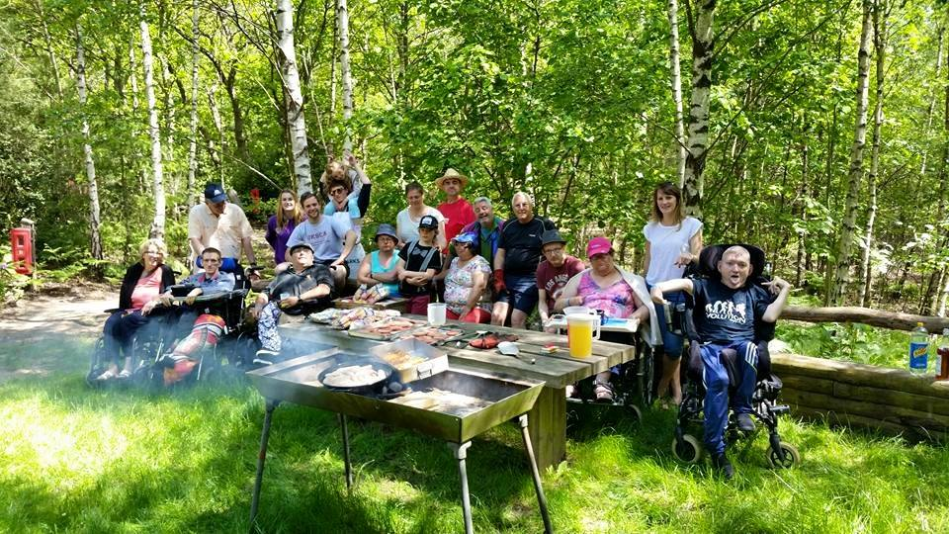

Where disability does not restrict your ability!

Location: ……………………………………
Date: .……………………………………….
Time: ……………………………………….

